**Digital ID Unification:**

There are 8 tables part of id unification which includes:

1. website_session_events
2. purchase_events
3. product_view_events
4. creditcard_banner_events
5. login_logout_events
6. promotion_tracking_events
7. add_to_wishlist_events
8. add_to_cart_events

Testing Results:

Add mock data in all cleaned tables to see it propagate to canonical tables:

1. website_session_events

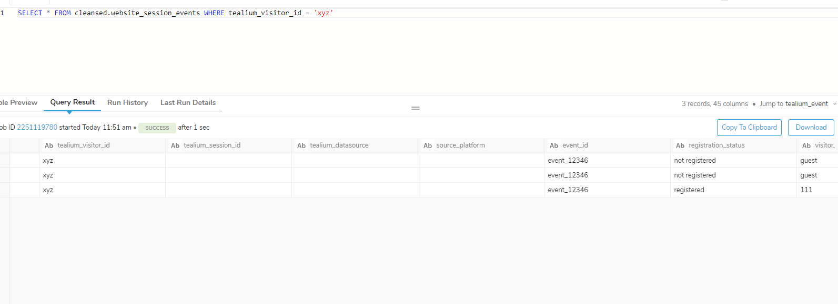

1. purchase_events

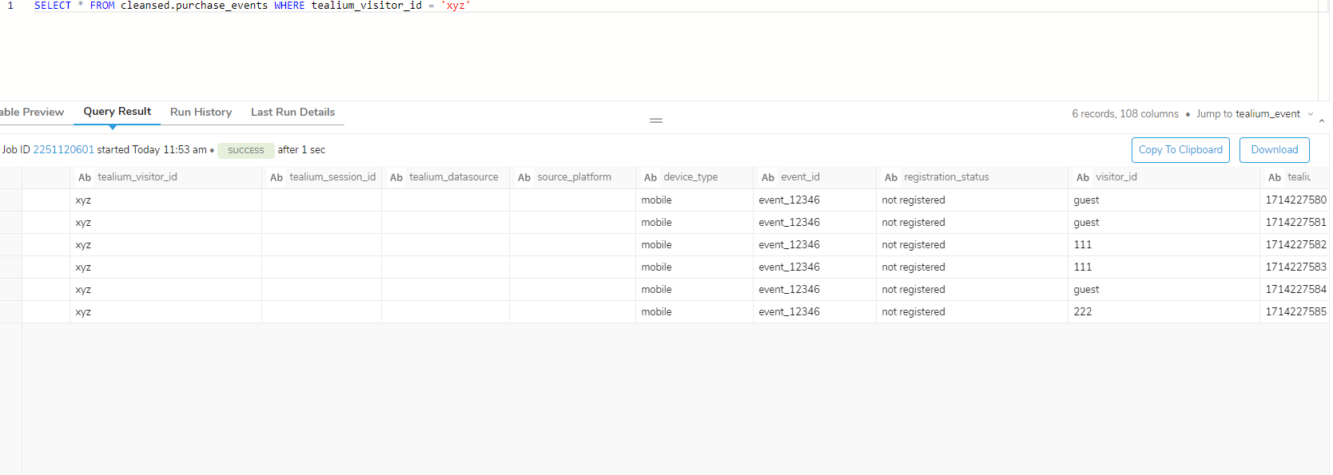

1. product_view_events

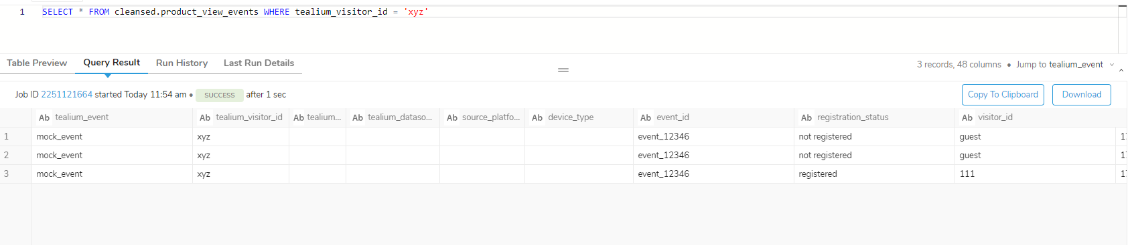

1. creditcard_banner_events

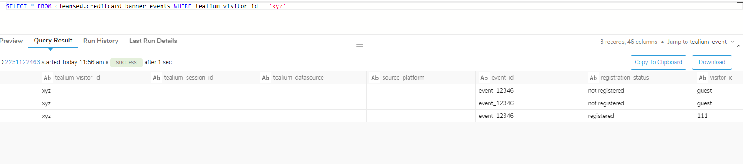

1. login_logout_event

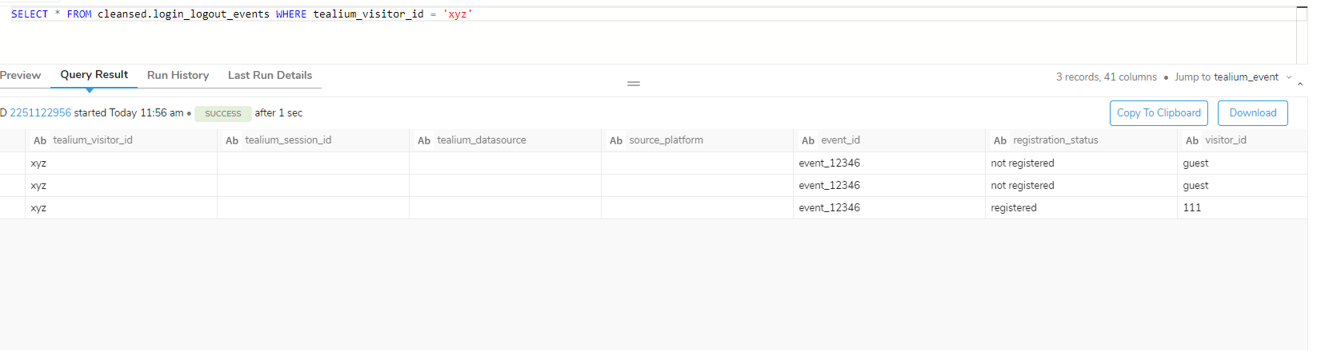

1. promotion_tracking_events

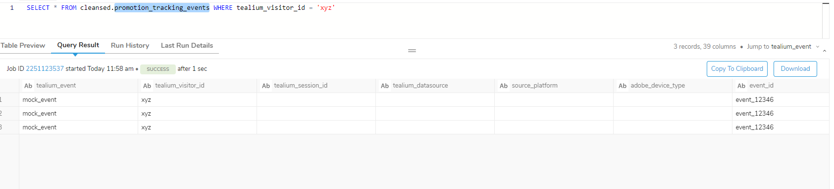

1. add_to_card_events

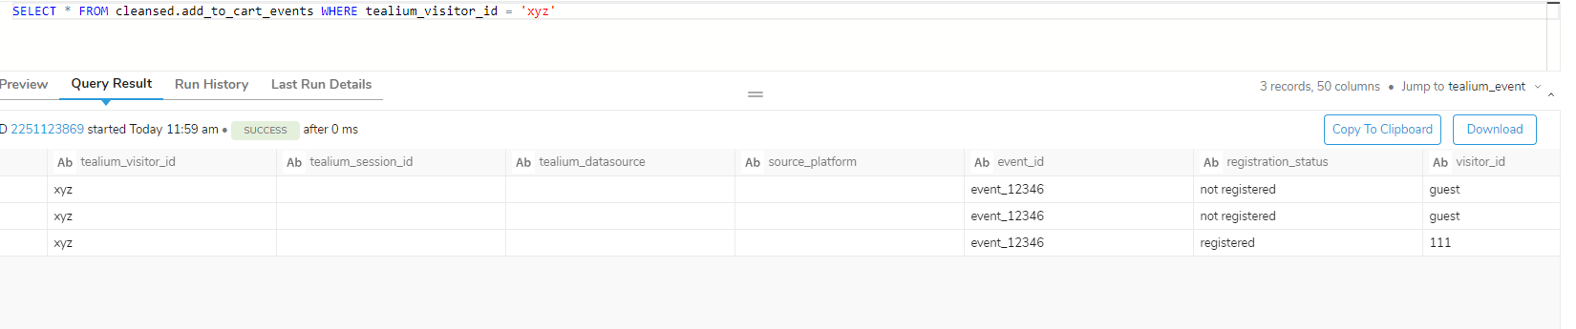

1. add_to_wishlist_events: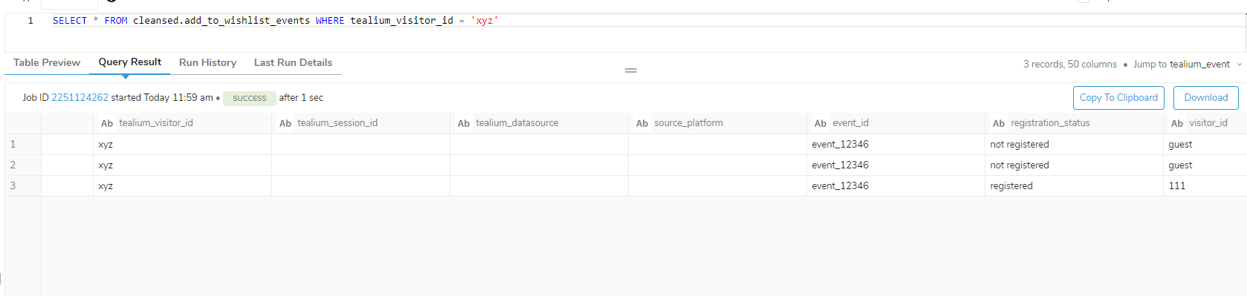

Run the Id unification Workflow:

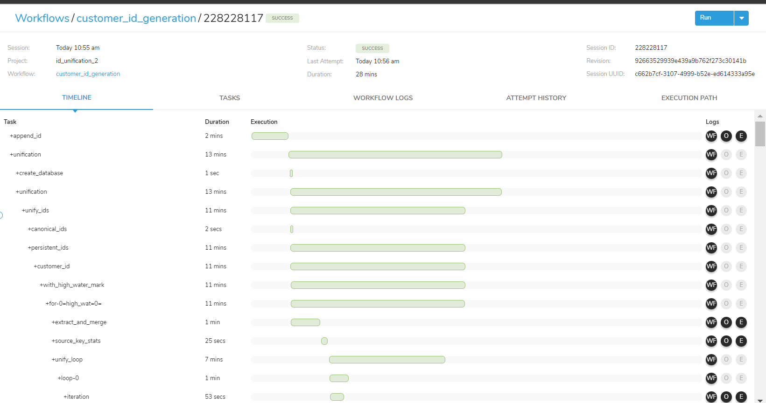

Check Id Prep Tables for all tables:

1. website_session_events_idprep

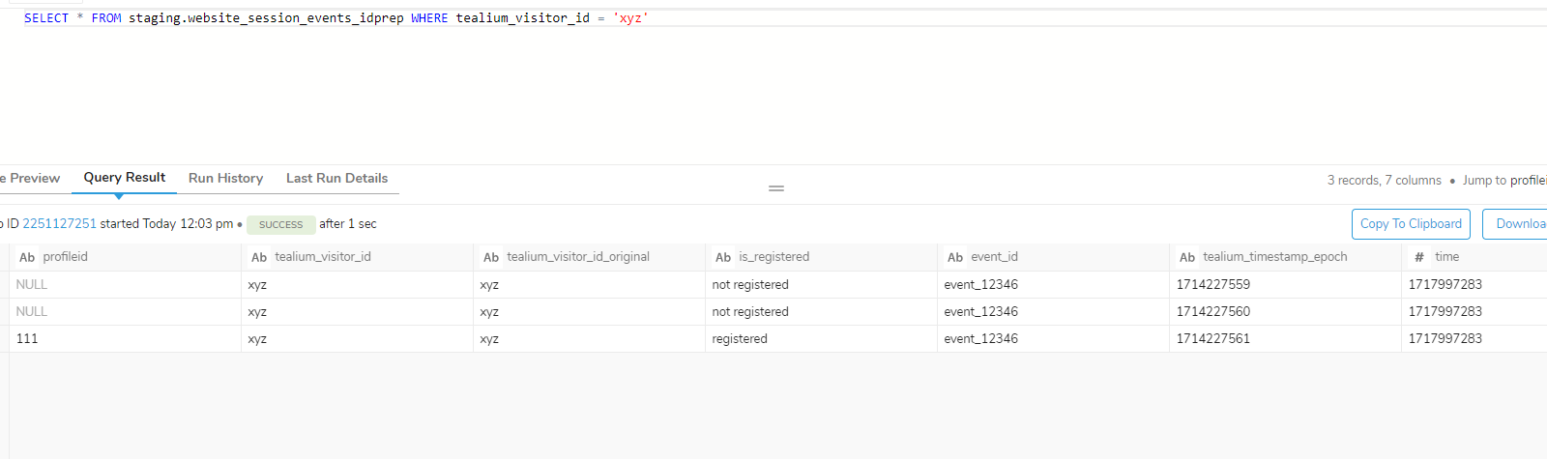

1. purchase_events_idprep

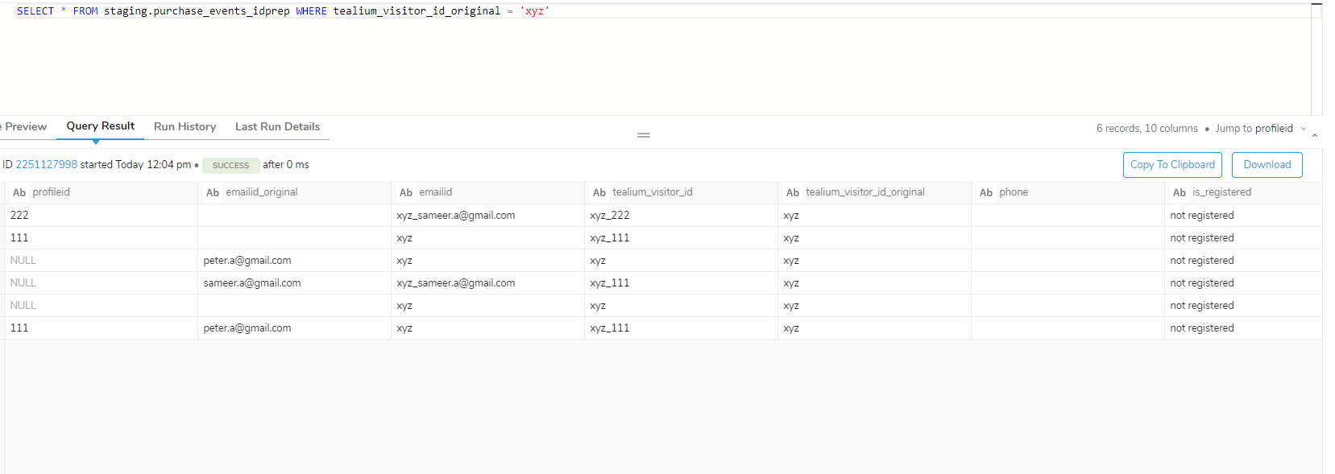

1. product_view_events_idprep

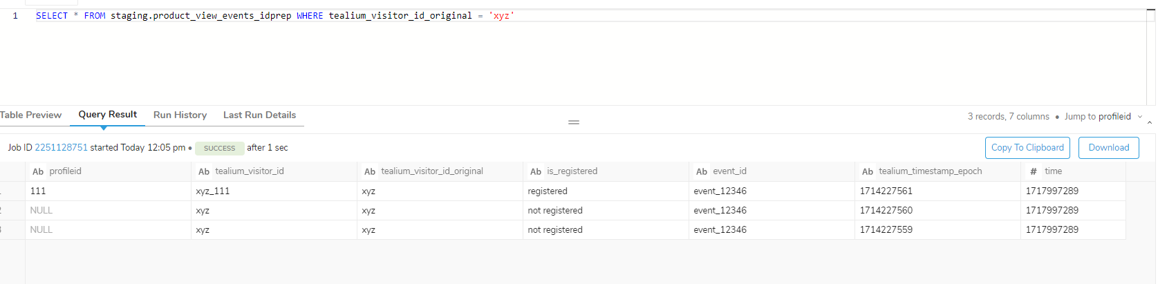

1. creditcard_banner_events_idprep

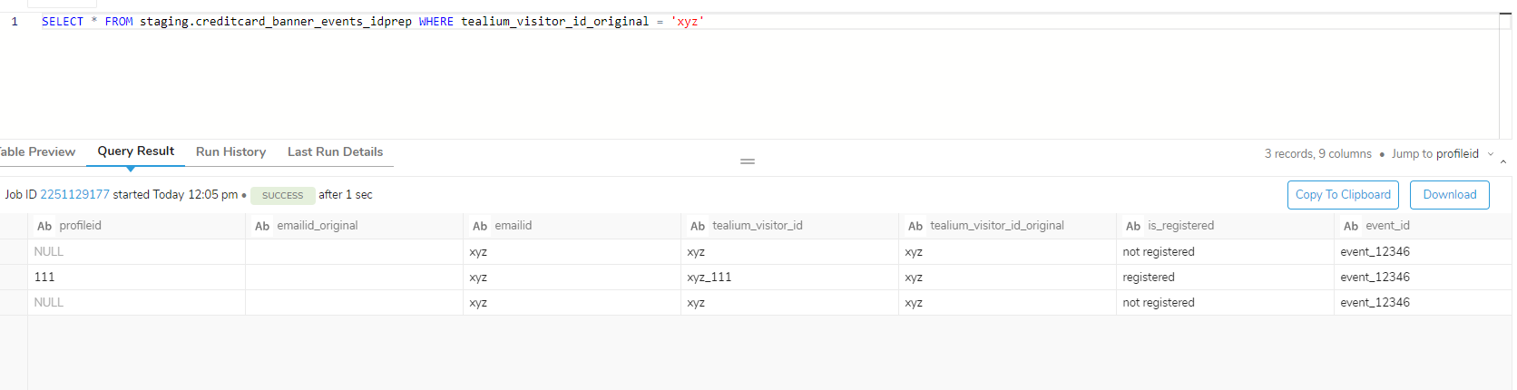

1. login_logout_events_idprep

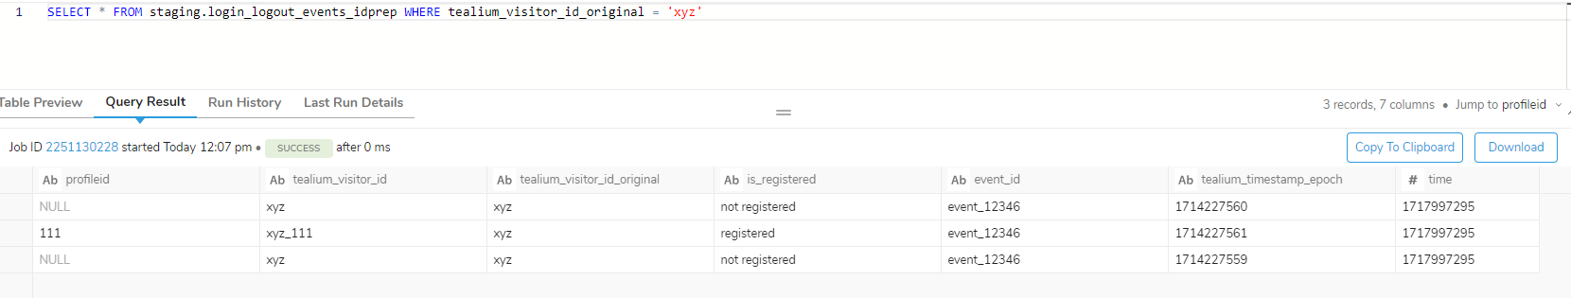

1. promotion_tracking_events_idprep

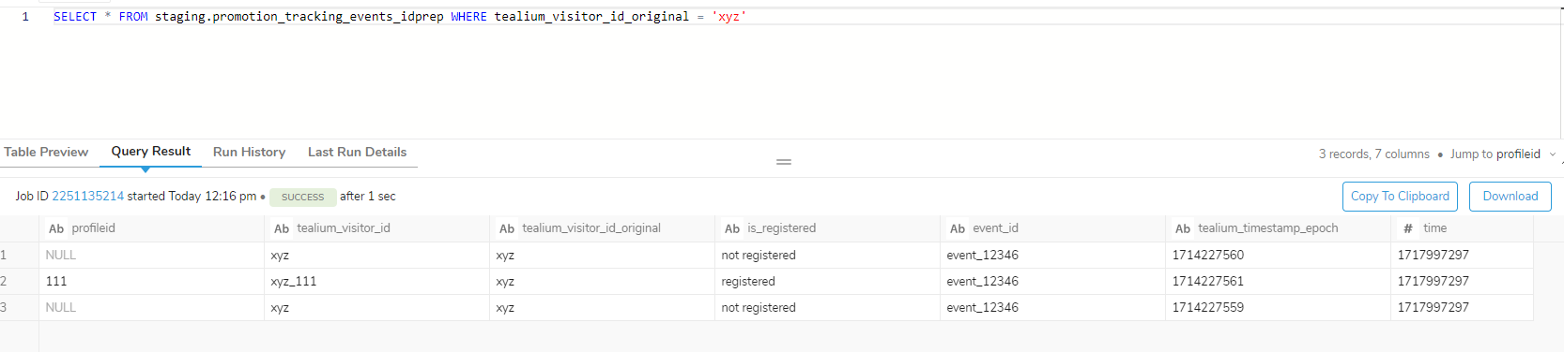

1. add_to_cart_events_idprep:

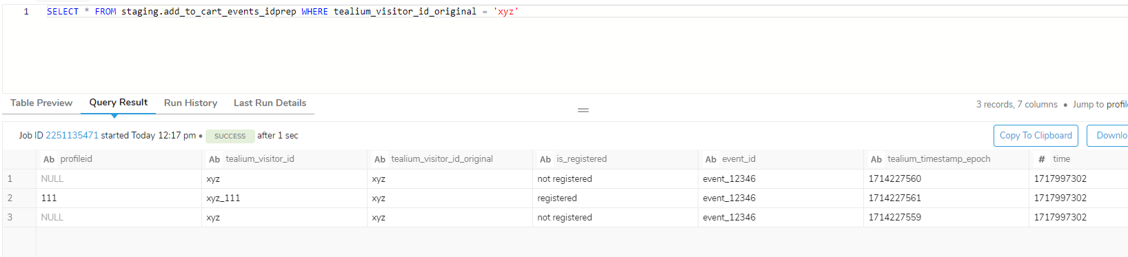

1. add_to_wishlist_events_idprep:

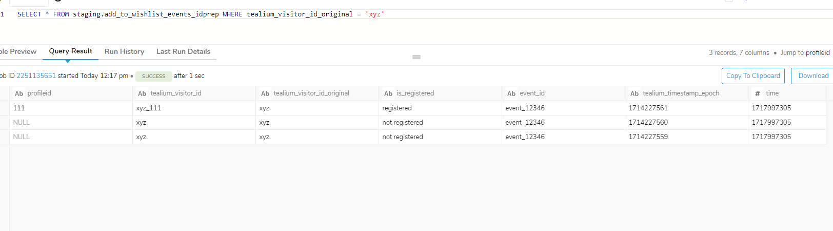

Master table:

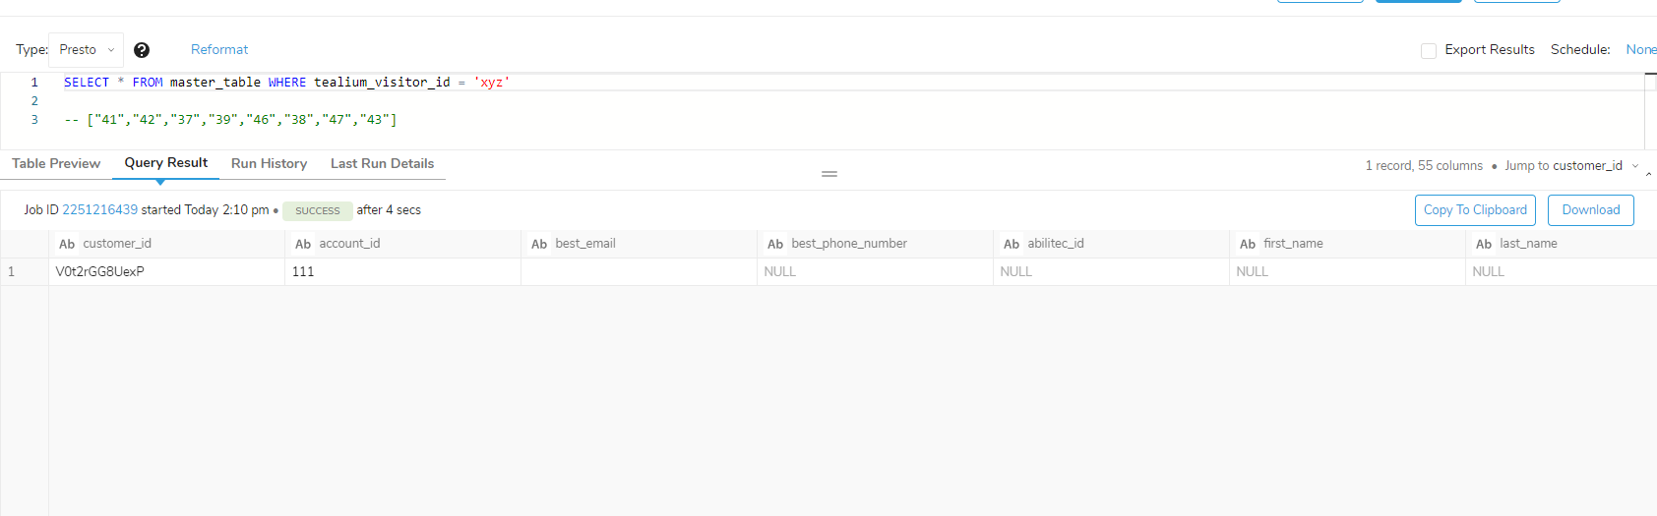

Canonical Tables:

1. website_session_events_canonical:

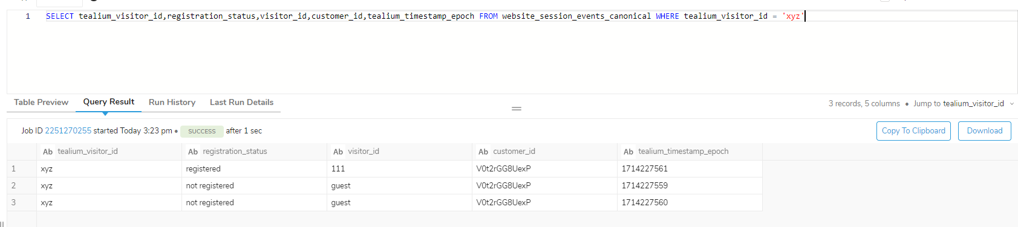

1. purchase_events_canonical:

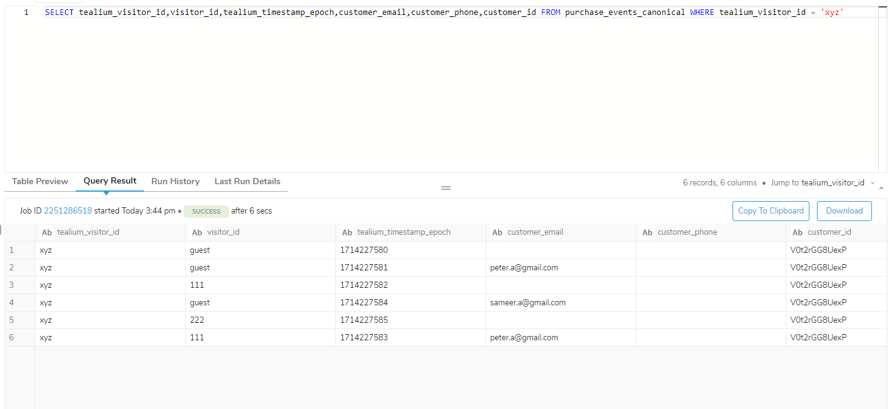

1. product_view_events_canaonical:

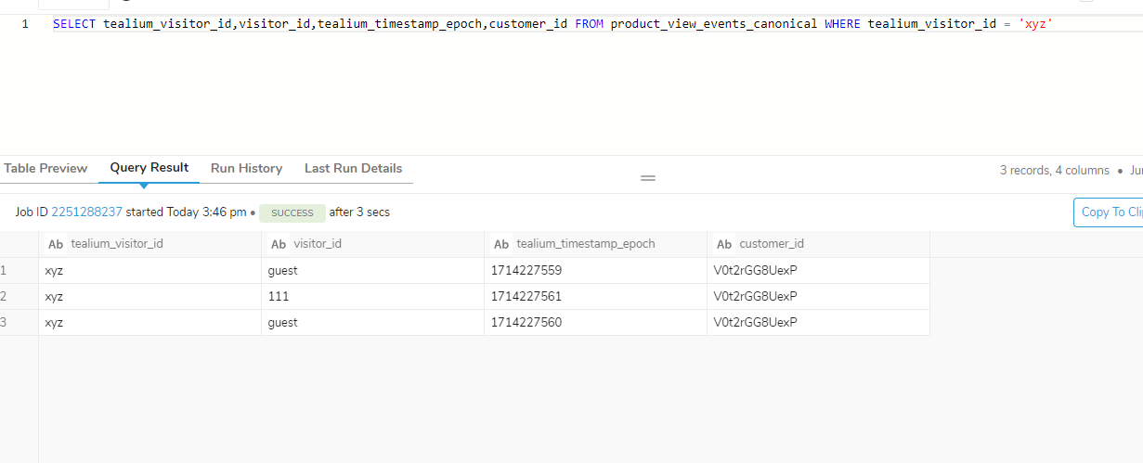

1. creditcard_banner_events_canaonical:

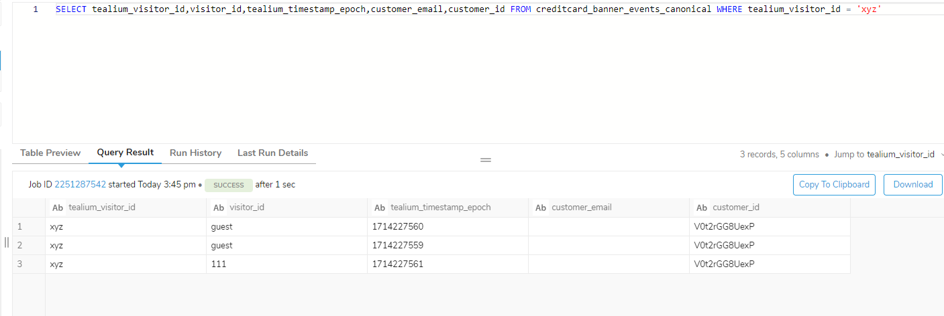

1. login_logout_events_canonical:

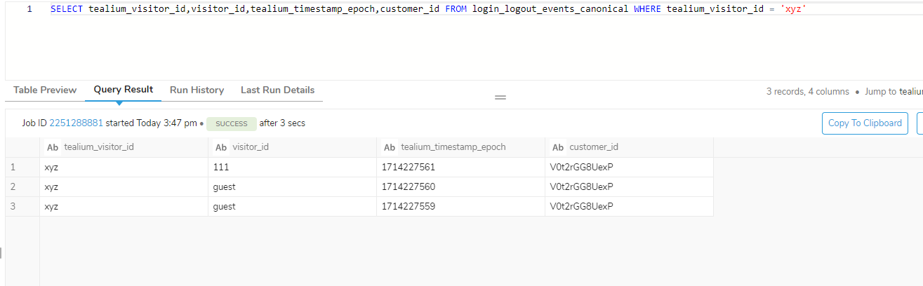

1. promotion_tracking_events_canonical

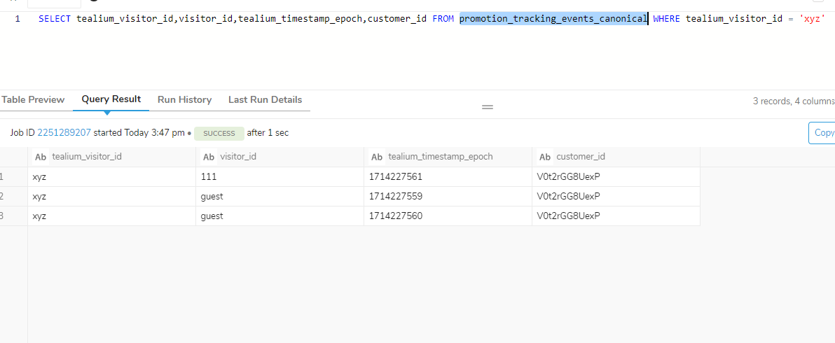

1. add_to_cart_events_canonical

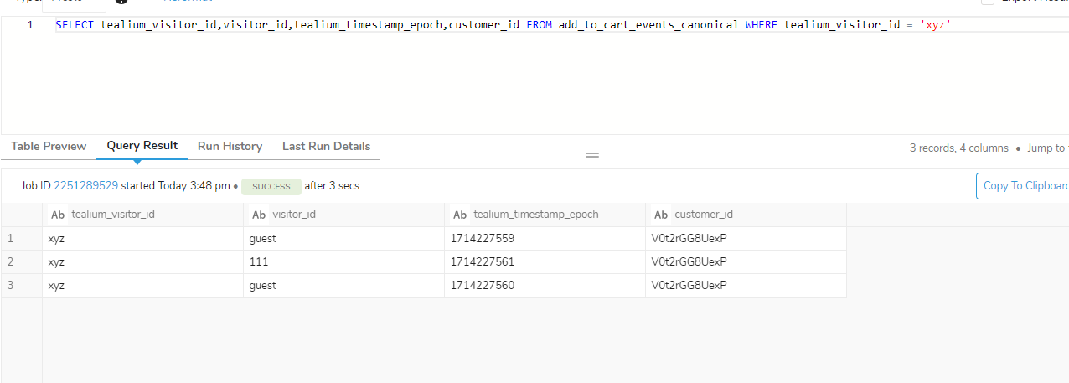

1. add_to_wishlist_events_canonical

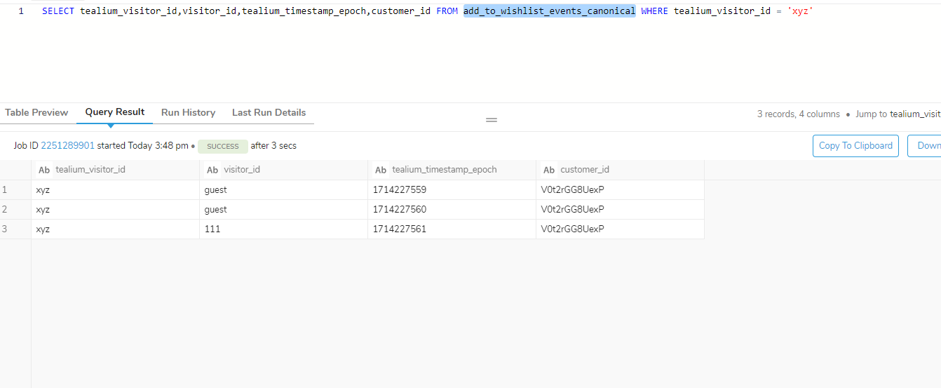

Customer master:

